CSA07 — Computer Networks

Assessment Tool 2 — Industry Problem Solving Task
Network Data Analysis: Traffic/Latency, Video vs VoIP, and VANET Congestion
Student Name:SHANUKA S K Reg. No.:1911260108
Tools used: Python (pandas, matplotlib) run in a local analysis environment — equivalent workflow to Google Colab / Excel.

Q1. Network Quality Dataset — Traffic vs Latency
Dataset: Network_Quality_Dataset_dataset.csv — 95,611 one-second samples of traffic_in_bps, traffic_out_bps, and latency_ms collected over roughly 27 hours.

Data Preparation
- Created a combined total_traffic_bps = traffic_in_bps + traffic_out_bps column.
- Found 14 rows (out of 95,611) with physically implausible traffic values in the terabit range — almost certainly sensor/logging glitches. These were removed before analysis (99.99% of the data was retained).

Understanding of the Industry Problem
The organization suspects that periods of higher network traffic are causing the slowdowns users are reporting. The practical question for engineering is whether latency tracks traffic volume closely enough that traffic load alone explains the slow periods — because that determines whether the fix is bandwidth-related (upgrade capacity, shape traffic) or something else entirely (queuing behaviour, a specific application, background load, or an unrelated bottleneck).

Analysis
Overall statistics (after cleaning): average latency 95.9 ms (min 14.6 ms, max 684 ms, std. dev. 35.3 ms); average total traffic 1.95 Mbps, with a maximum of ~61.9 Mbps.
Correlation: Pearson correlation between total traffic and latency = -0.003 (traffic_in: 0.004, traffic_out: -0.01) — i.e., essentially zero linear correlation.
Traffic load was split into five equal-sized quintiles (lowest 20% of traffic readings to highest 20%) and the average latency was computed for each group:
Traffic quintile | Traffic range (approx.) | Average latency (ms)
Q1 (lowest) | 0 – 1.21 Mbps | 97.7
Q2 | 1.21 – 1.86 Mbps | 95.7
Q3 | 1.86 – 2.15 Mbps | 94.4
Q4 | 2.15 – 2.62 Mbps | 95.9
Q5 (highest) | 2.62 – 61.9 Mbps | 96.0
The average latency is essentially flat (94–98 ms) across every traffic quintile — the busiest 20% of one-second samples are no slower, on average, than the quietest 20%. This was checked a second way by isolating the worst latency events directly: the 505 readings with latency above 200 ms averaged only 2.39 Mbps of traffic — close to the dataset-wide average of 1.95 Mbps, and far below the observed 61.9 Mbps peak. The single highest latency spike recorded (684 ms) occurred at just ~1.07 Mbps of traffic, a below-average load.
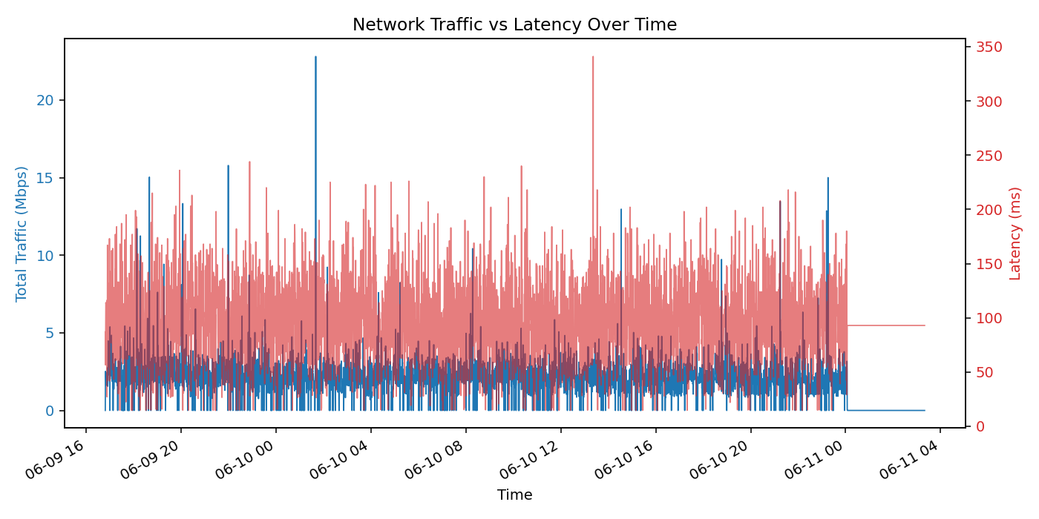
Figure 1. Total traffic (blue, Mbps) and latency (red, ms) over the monitoring window.
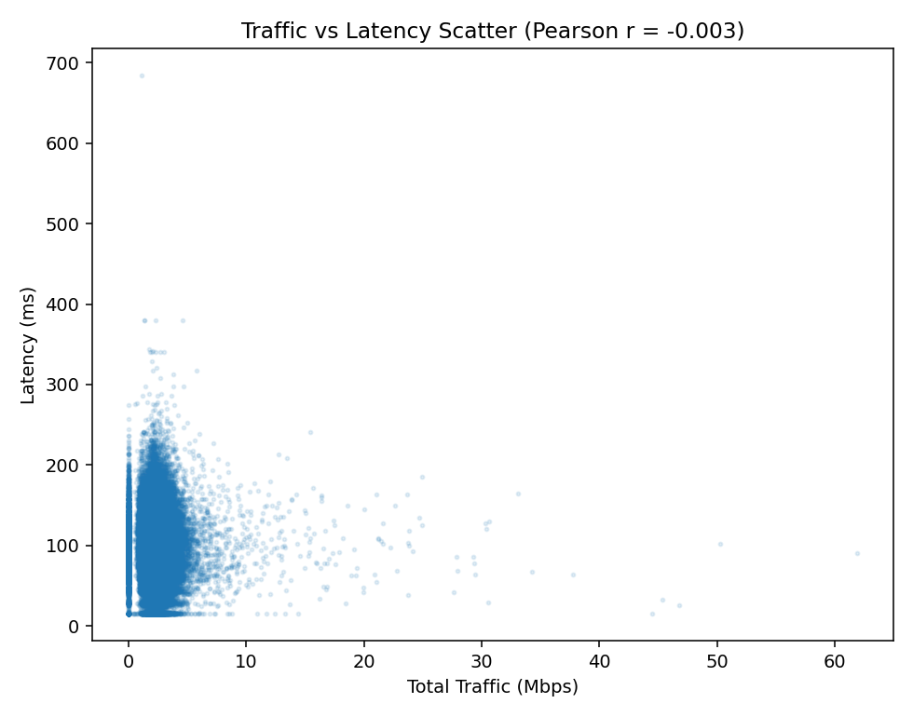
Figure 2. Scatter plot of every reading — traffic vs. latency shows no visible trend.
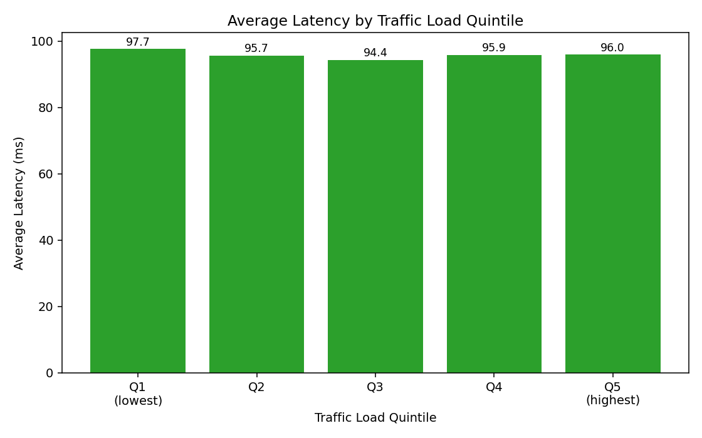
Figure 3. Average latency is nearly identical across all five traffic-load quintiles.

Identified Industry Problem
The data does not support the organization's working assumption. Latency spikes in this network are not associated with higher traffic volume — they occur just as often, and just as severely, during low-traffic periods as during high-traffic ones. This points to the real problem being something other than raw bandwidth demand: most likely intermittent queuing/jitter, a background process, DNS/upstream delay, or a device-level issue that fires independently of how much data is currently flowing.

Recommended Solution
Because bandwidth utilization does not explain the slow periods, simply adding more bandwidth is unlikely to fix user-perceived slowness. The single most useful next step is to deploy continuous latency/jitter monitoring (e.g., active ICMP/TWAMP probes or QoS monitoring at the router) correlated with device-level logs (CPU, buffer/queue depth, interface errors) during the exact timestamps of latency spikes — rather than traffic volume — to pinpoint the real cause. As a low-cost interim improvement, enabling QoS-based traffic prioritization (e.g., prioritizing latency-sensitive traffic in the queue) is still worth doing as good practice, but the data indicates the team should redirect its investigation away from 'traffic volume' and toward queuing/processing delay as the more likely root cause.

Q2. Video Streaming (TCP) vs VoIP (UDP)
Dataset: network_traffic_dataset.csv — 89,709 captured packets labelled by Activity_Type (Video_Streaming / VoIP_Call), Protocol, and Length (bytes). Video_Streaming traffic runs almost entirely over TCP/TLSv1.3 (77,725 packets); VoIP_Call traffic runs almost entirely over UDP/STUN/RTCP (11,984 packets) — consistent with the expected TCP-vs-UDP split for these two application types.

Understanding of the Industry Problem
The company shares one network for video meetings and voice calls. Network engineers need to know whether these two traffic types actually behave differently at the packet level, because if they do, treating them identically in the network's queue/QoS policy is a missed opportunity — and if the network gets congested, someone has to decide which traffic gets priority.

Analysis
Metric | Video Streaming (TCP) | VoIP Call (UDP)
Packet count | 77,725 | 11,984
Average packet length | 1,330.4 bytes | 175.5 bytes
Median packet length | 1,514 bytes (MTU-sized) | 172 bytes
Std. deviation | 482.6 bytes | 86.1 bytes
Min / Max length | 54 / 1,514 bytes | 60 / 480 bytes
Average inter-arrival time | ≈8 ms (bursty — large std. dev.) | ≈52 ms (regular, low std. dev.)
Video Streaming packets are, on average, 7.6× larger than VoIP packets and cluster tightly around the 1,514-byte Ethernet MTU — the traffic is bulk-transferring large chunks of video data whenever the TCP window allows, arriving in short, uneven bursts (mean gap ~8 ms but highly variable). VoIP packets are consistently small (mostly well under 200 bytes, matching the small, fixed-size voice samples UDP carries) and arrive far more regularly and predictably (mean gap ~52 ms with low variance) — this is expected, since voice codecs generate a steady stream of small samples at a fixed rate, and UDP does not buffer or batch them the way TCP can.
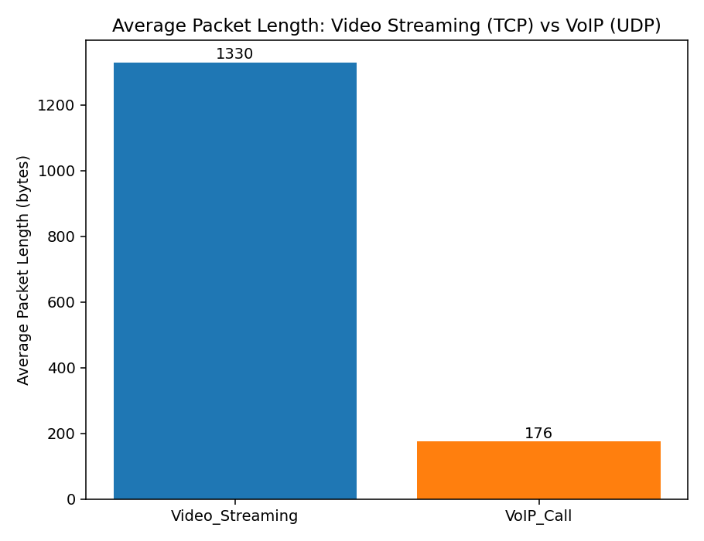
Figure 4. Average packet length: Video Streaming vs VoIP.
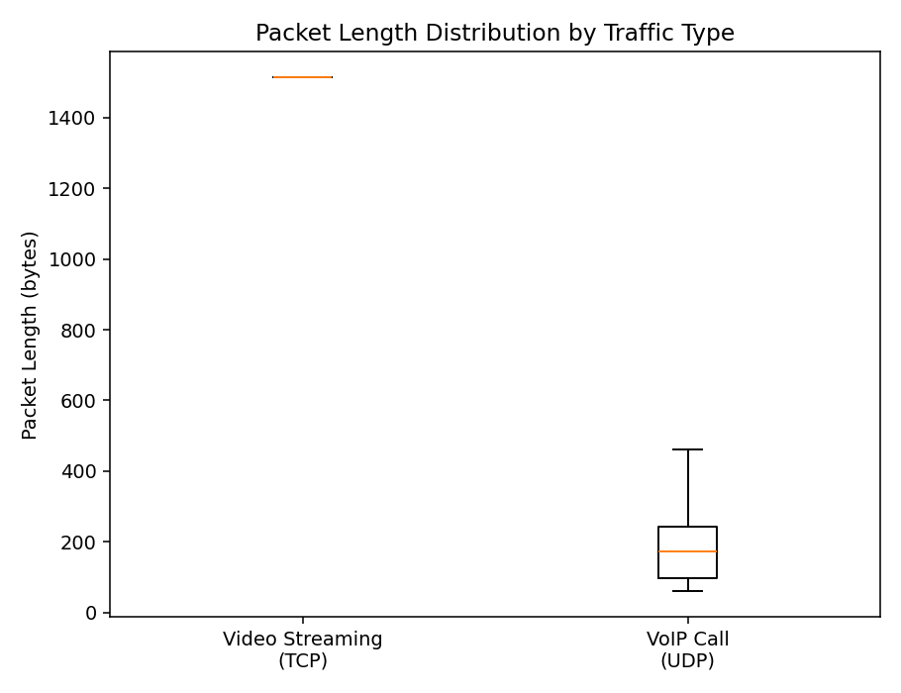
Figure 5. Packet-length distribution (box plot, outliers hidden for readability).
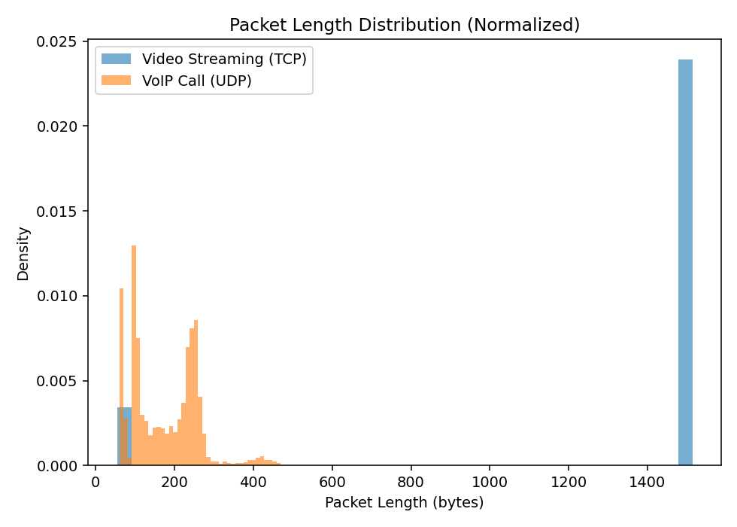
Figure 6. Normalized packet-length distributions — Video Streaming clusters near the MTU; VoIP clusters near 150–200 bytes.

Identified Industry Problem
The two traffic types have fundamentally different communication characteristics: Video Streaming is large-packet, bursty, throughput-hungry, and (being TCP-based) tolerant of brief delay because it can buffer and retransmit. VoIP is small-packet, low-bandwidth, but timing-sensitive — it has no retransmission (UDP) and depends on packets arriving at a steady, predictable rate; even small added delay or jitter is immediately audible as call quality degradation. Treating both types identically in a single best-effort queue means that, under congestion, VoIP's small time-critical packets can get stuck behind Video Streaming's much larger bursts.

Recommended Solution
VoIP (UDP) traffic should receive higher priority during network congestion — for example via a QoS/DiffServ marking (EF — Expedited Forwarding) and a dedicated low-latency queue for UDP voice traffic, using something like a low-latency queuing (LLQ) or priority queuing (PQ) policy on the router/switch. The justification is that VoIP has a small, fixed, low bandwidth footprint but a strict delay/jitter budget it cannot recover from (no retransmission, human-perceptible degradation), whereas Video Streaming's TCP-based delivery can absorb brief queuing delay through buffering without the user noticing, and its much larger packets are exactly the traffic that should yield the queue to time-critical voice packets rather than the other way around.

Q3. VANET Traffic Congestion Dataset
Dataset: vanet_traffic_data.csv — 195,714 vehicle-to-vehicle communication records labelled by road congestion state (Free-flow, Moderate, Heavy, Gridlock), with packet_loss_pct, avg_comm_delay_ms, queue_length_veh, and channel_busy_ratio_pct recorded alongside traffic/road metrics for each record.

Understanding of the Industry Problem
A smart-transportation company relies on vehicle-to-vehicle (V2V) wireless communication to support safety and traffic-management applications. As roads become more congested, more vehicles are competing for the same limited wireless channel at the same time. The company needs to know at which congestion level this channel contention starts to seriously degrade communication reliability, so it can decide where to intervene.

Analysis
Average value of each metric was calculated for every one of the four congestion states:
Congestion state | Records | Packet loss (%) | Comm. delay (ms) | Queue length (veh) | Channel busy ratio (%)
Free-flow | 57,812 | 0.52 | 20.1 | 2.0 | 10.1
Moderate | 54,018 | 5.01 | 49.9 | 10.0 | 29.9
Heavy | 47,440 | 15.07 | 100.6 | 25.2 | 60.1
Gridlock | 36,444 | 29.90 | 199.3 | 59.8 | 89.8
Every metric worsens monotonically and steeply as congestion increases. From Free-flow to Gridlock: packet loss rises roughly 57× (0.52% → 29.9%), communication delay rises roughly 10× (20.1 ms → 199.3 ms), queue length rises roughly 30× (2.0 → 59.8 vehicles), and channel busy ratio rises roughly 9× (10.1% → 89.8%, i.e., the shared wireless channel is almost saturated). The largest jump for every metric happens between Heavy and Gridlock — e.g., packet loss roughly doubles again (15.1% → 29.9%) and delay roughly doubles again (100.6 ms → 199.3 ms) in that final step, a steeper increase than any of the earlier transitions.
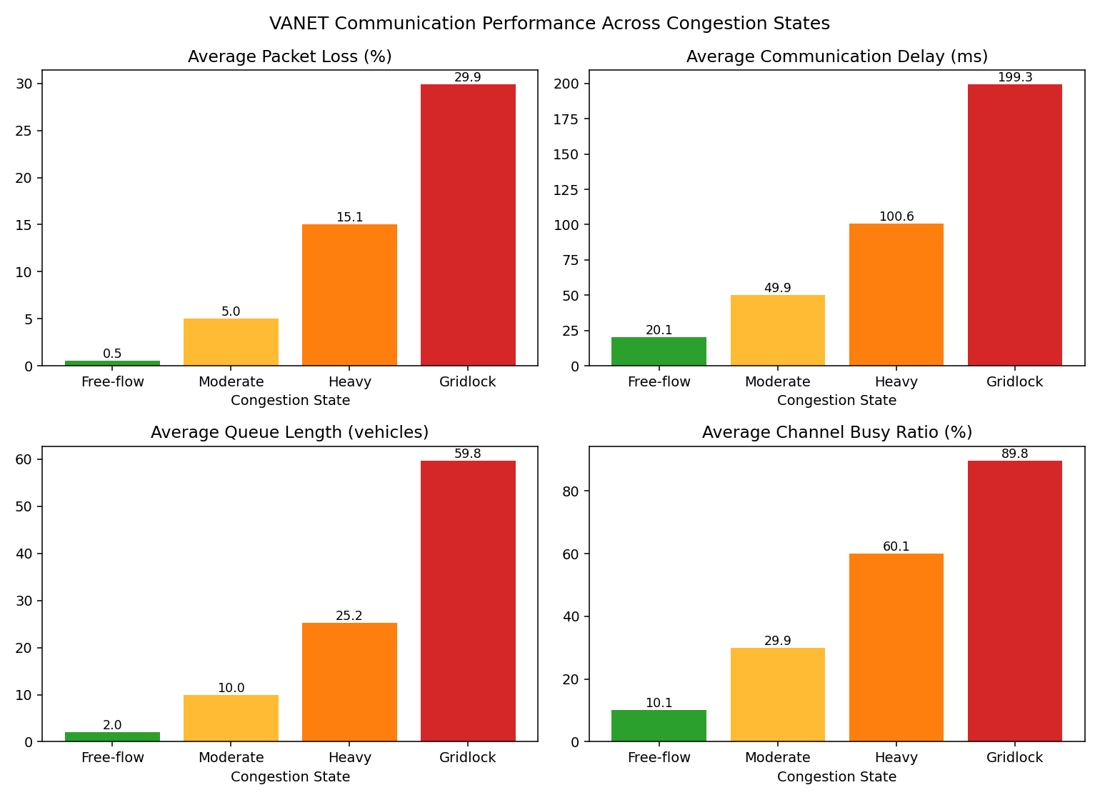
Figure 7. All four communication metrics across the four congestion states.
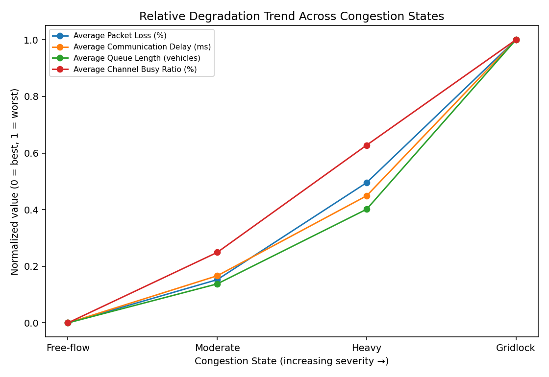
Figure 8. Normalized (0–1) trend line showing all four metrics degrading together as congestion worsens, steepest between Heavy and Gridlock.

Identified Industry Problem
Communication reliability becomes significantly worse at Gridlock. It is not just the worst state on average — the rate of degradation accelerates going into it: the channel busy ratio near 90% indicates the wireless medium itself is close to saturated, meaning vehicles are spending most of their time waiting for channel access rather than successfully transmitting, which directly explains both the near-30% packet loss and the roughly 200 ms average delay. In a safety-critical V2V context, a packet-loss rate approaching 30% and a ~200 ms delay at exactly the moment (severe congestion, many nearby vehicles) when timely hazard/collision warnings matter most is the highest-risk failure mode in the dataset.

Recommended Solution
Introduce congestion-aware channel access control at the network level — specifically, dynamic transmit-power and message-rate adaptation (a standard VANET congestion-control approach) that automatically reduces each vehicle's beacon rate and/or transmit power as local channel busy ratio rises, freeing up airtime for the channel rather than letting every vehicle keep transmitting at a fixed rate into an already-saturated medium. This directly targets the measured bottleneck (channel busy ratio at ~90% during Gridlock) rather than the symptoms, and is a practical, low-cost software/firmware-level change to the V2V communication stack rather than new infrastructure.

